Steps to implement SonarQube on your project
through Sonar-Maven plugin

Step1: Download SonarQube community build version form the given link .
Link: https://www.sonarsource.com/products/sonarqube/downloads/
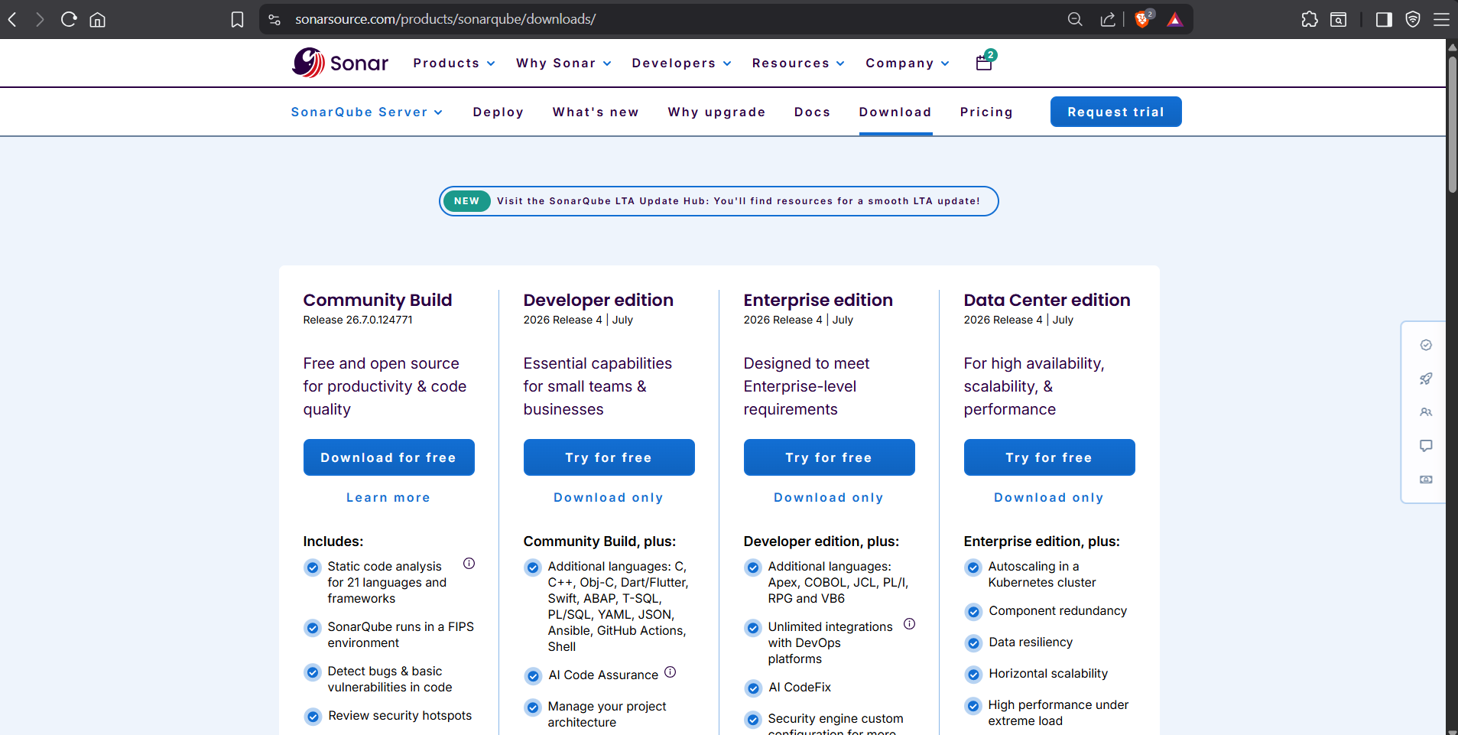

Step 2 : Extract the zip file content and store it in your desirable folder
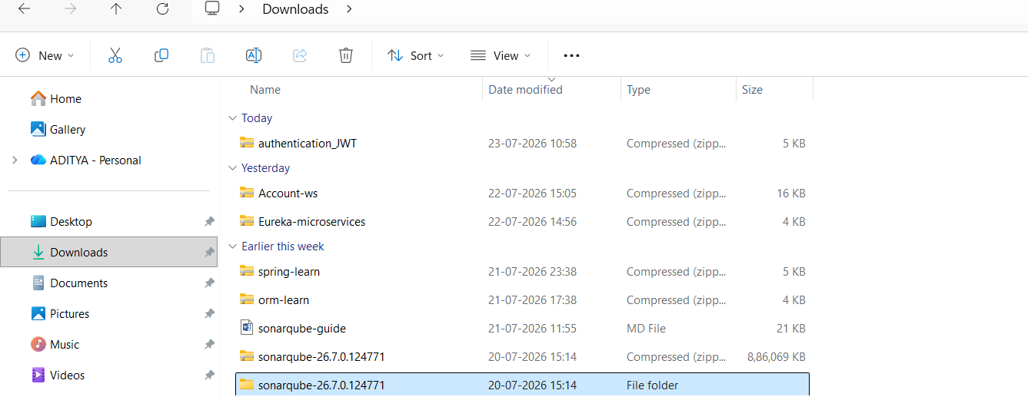

You can See I have extracted the SonarQube file in my Downloads folder.
Step 3 : After Extracting the file Go inside SonarQube File and navigate to folders as shown below:
sonarqube-26.7.0.124771binwindows-x86-64click on Start sonar option

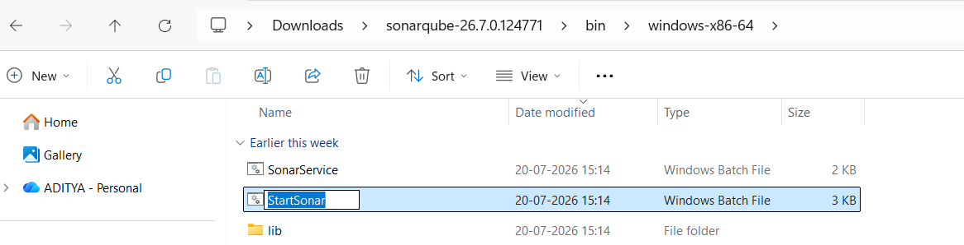

After clicking on Start Sonar Option You be redirected to command prompt and after waiting for some time you will get output “SonarQub is Operational”. this means SonarQube is started.

Note : if StartSonar is not Working on your system, check if you have installed java JDK version 21 or higher by typing java --version on your command prompt
Then do the following steps
- Open command prompt and go to the destination folder where you have kept your SonarQube.
- Type cd bin
- Type cd windows-x86-64
- Type StartSonar.bat
After this You will see text like “ Starting SonarQube…”

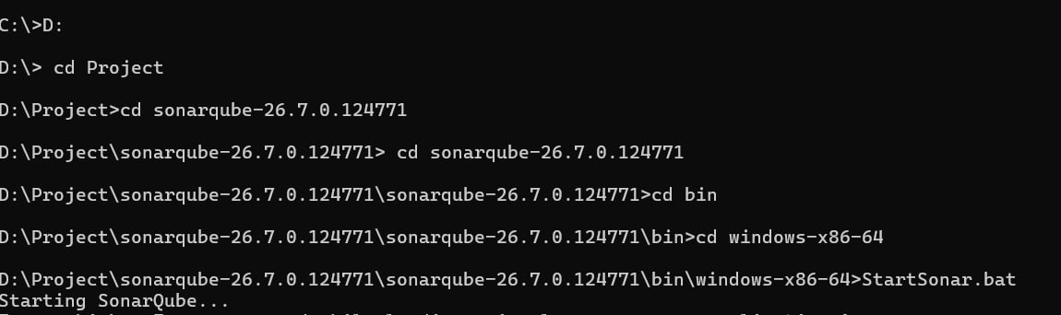

Step 4 : Now we will go to our web browser and type this URL : http://localhost:9000/
This is the default port number for SonarQube.
After going to the above Port number you will see a welcome page along with Username Password Interface .
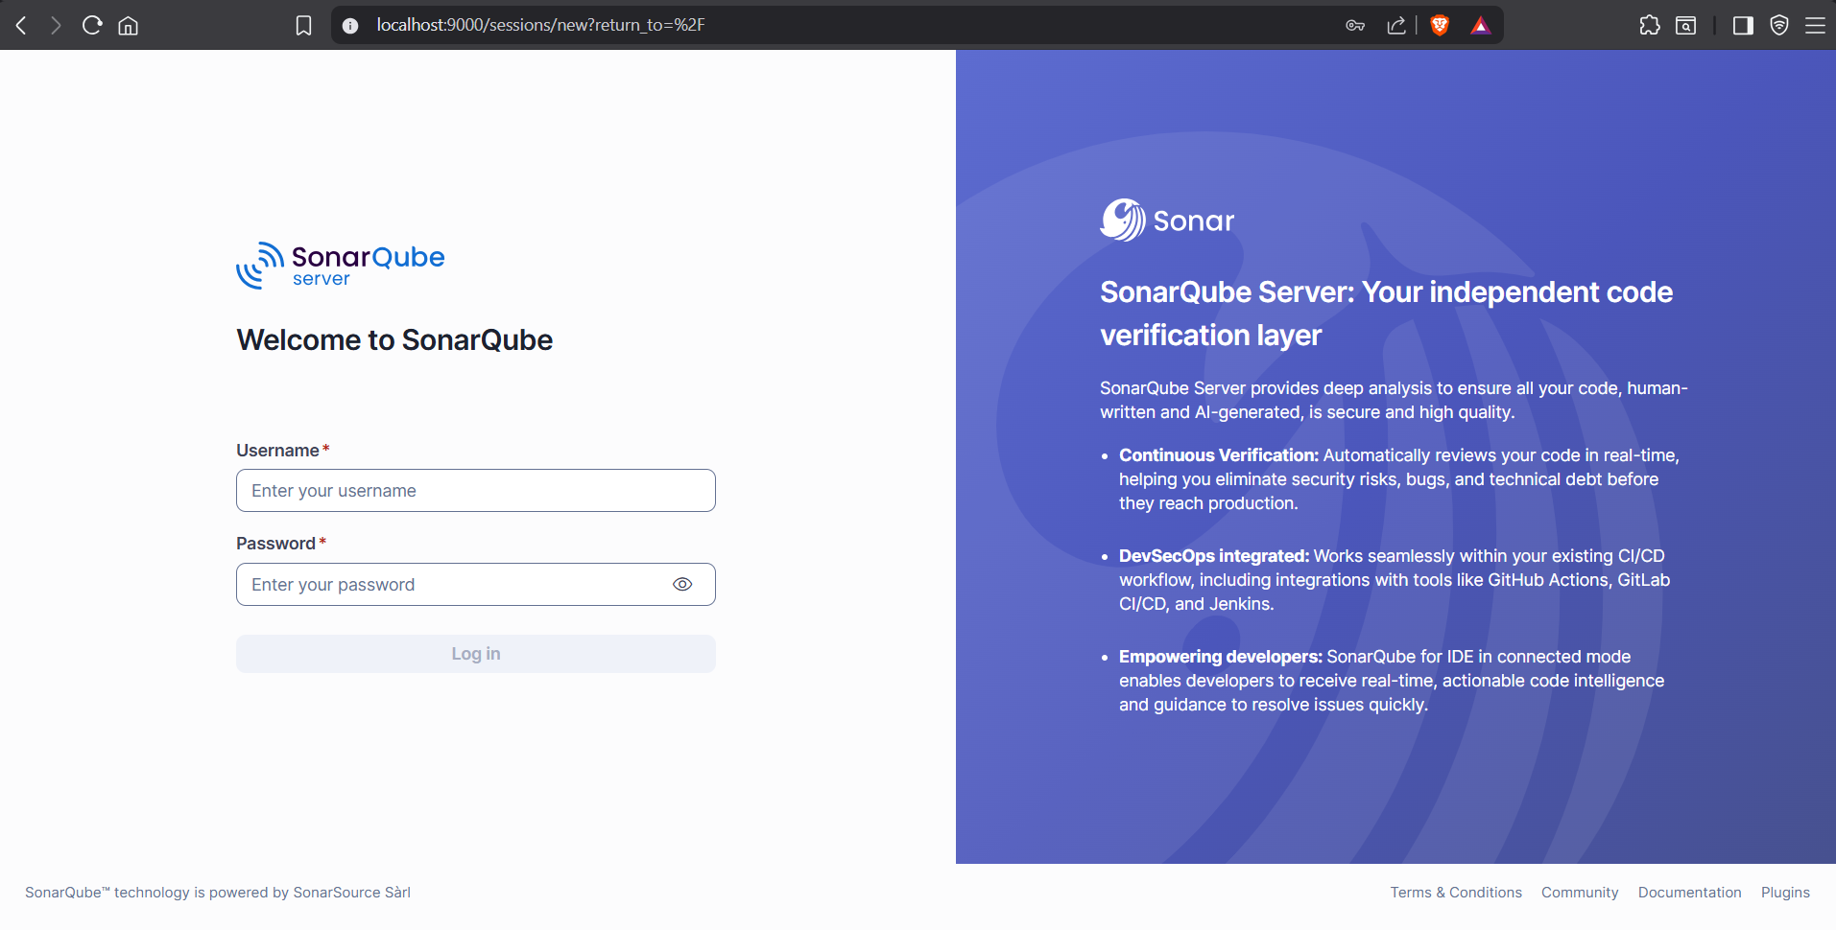

If you are logging-in for the first time your default Username and Password will be :
Username = admin
Password=admin
Enter this username and password and you will be logged-in.

Step 5 : After entering default username password a page will open that will say change your password.
Here you will have to make your new password and that will be used whenever you will try to login SonarQube so better remember it .
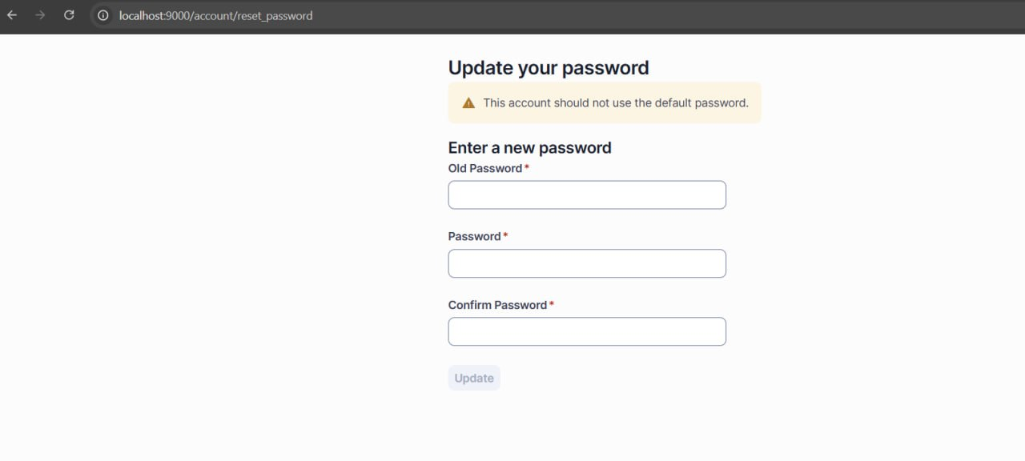

Step 6 : Now After this step you will get welcome screen where you will be asked to create your project .
There you have to select option create a local project .
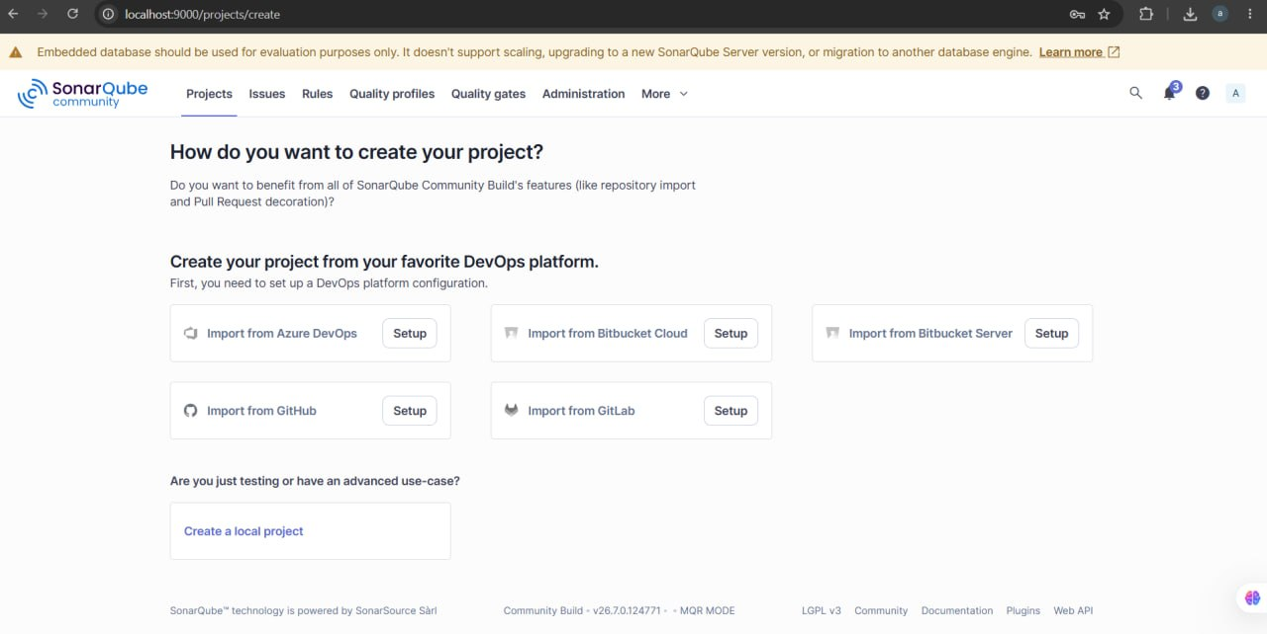

After clicking On the create a local project option a interface will be open where you have to type:
your project display name
Project key
And main branch name (keep the main branch name main)
After filling all the above field click next
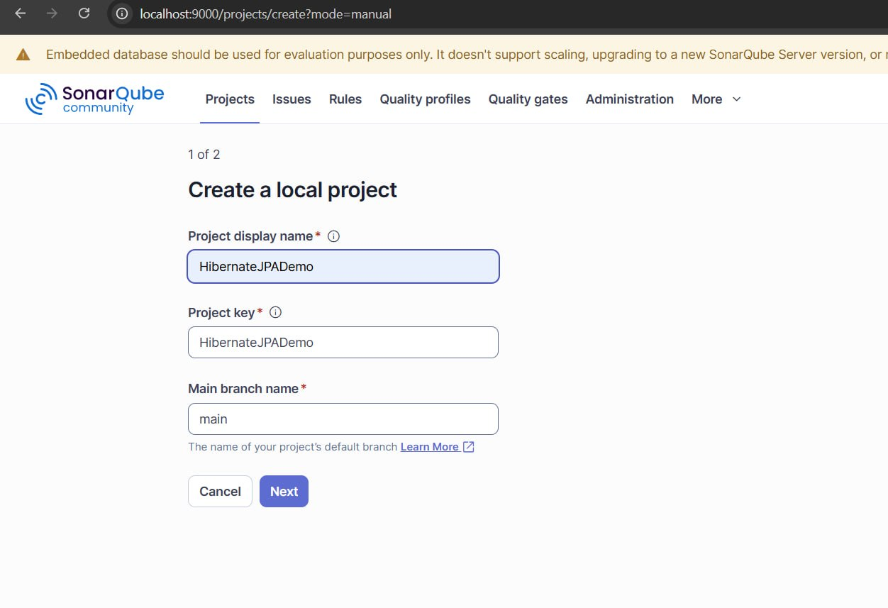
After this you will be asked “set up new code for project “ here you have to select “follows the instance’s default “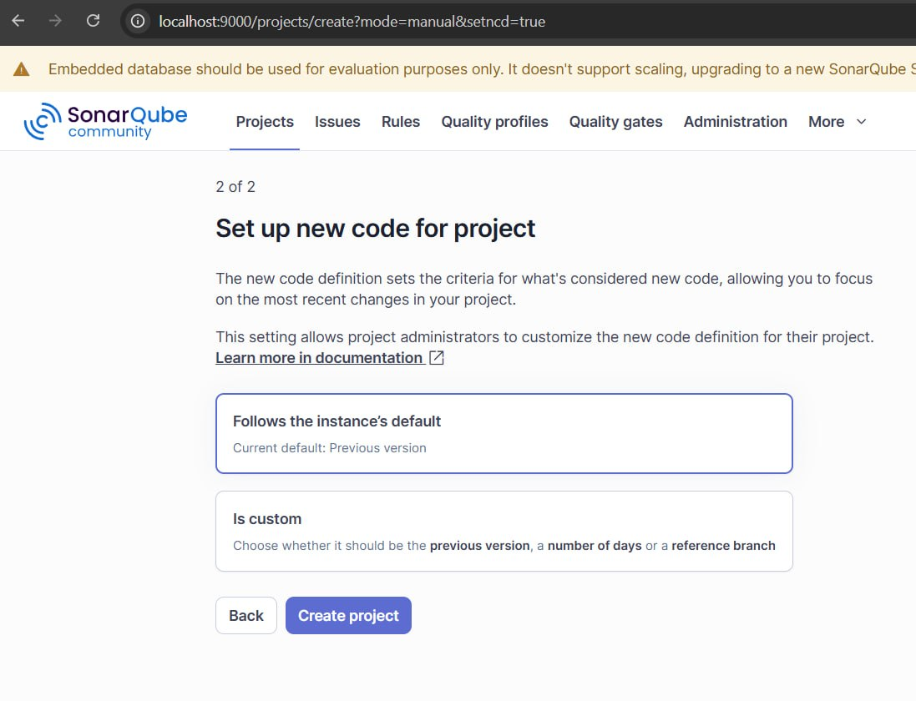
Step 7:
After doing above process you will get inside your project and you will have to select a method on how you want to analyse your repository .
Here we are doing SonarQube setup through maven so we will choose “Locally option”
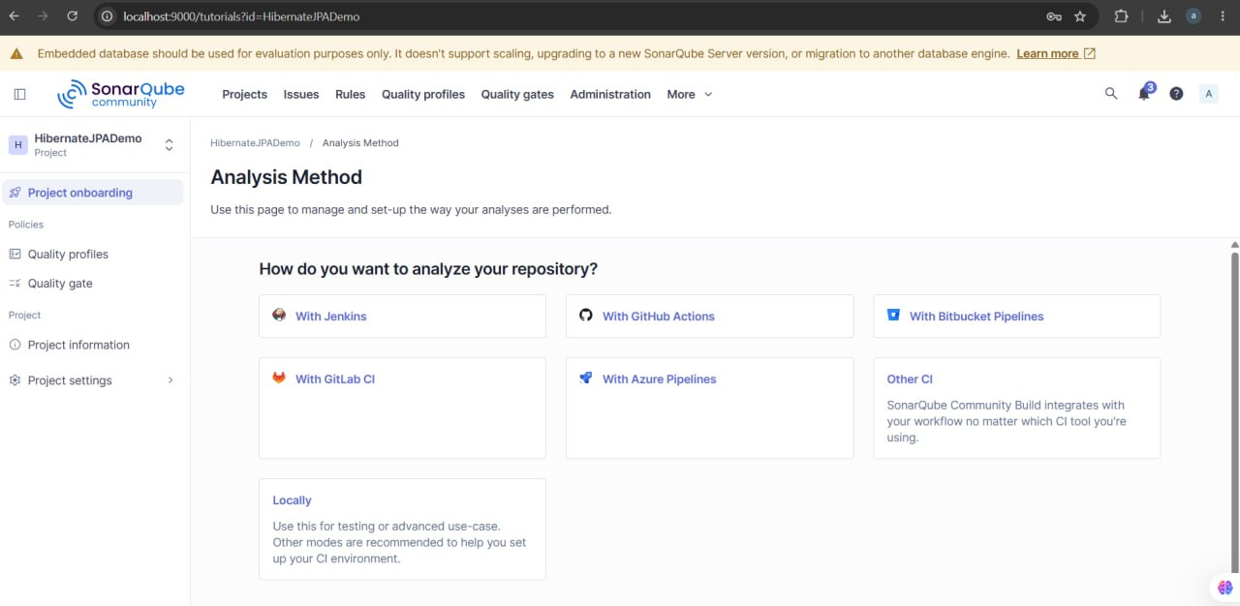

TOKEN GENERATION FOR OUR PROJECT
After selecting locally option you will have to generate a token which will be used later for identification while analysis of your project
For doing this you will have a interface in which you can see “provide a token”
Where in Token name field your project name will be written and duration will be 30days
After this click on “Generate” and your token will be generated .
Note: you will have to generate this token separately for every project you made in SonarQube
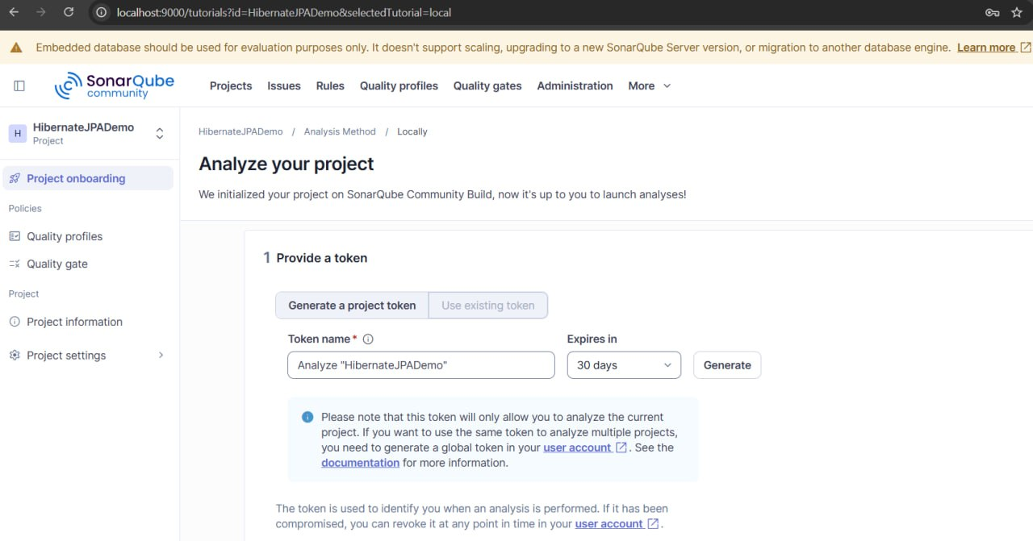
After generating token you will get a option to select which developer tools you are using in your project , so we are doing this on maven so we will select maven
And after selecting maven you will get a set of commands , copy that commands we will use it in future on our project terminal(Step 9)
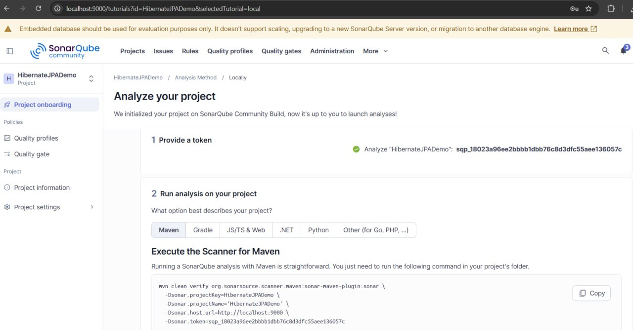
Step 8 : Now open your project in intelij idea and after opening that open pom.xml file in that go inside <plugins></plugins> tag and paste the below plugin

<plugin>
<groupId>org.sonarsource.scanner.maven</groupId>
<artifactId>sonar-maven-plugin</artifactId> <version>5.1.0.4751</version>
</plugin>

After Pasting this plugin reload your pom.xml.
Step 9:
Now we will paste the code that we have copied in Step 7 on terminal
mvn clean verify org.sonarsource.scanner.maven:sonar-maven-plugin:sonar \
-Dsonar.projectKey=HibernateJPADemo \
-Dsonar.projectName='HibernateJPADemo' \
-Dsonar.host.url=http://localhost:9000 \
-Dsonar.token=”Your project token ”

DO NOT PASTE ABOVE COMMAND ON TERMINAL

Before pasting do these things
- If you will paste above code you will get Error mvn command not found
Because we have not installed maven on our system we are using maven wrapper. To tackle this we will change mvn to .\mvnw
- After doing above changes we will make sure there is no space between our commands if you directly copy paste it it will throw error so make sure to remove space from the command
This is the correct pattern of command that you can paste in your intellij idea terminal

.\mvnw.cmd --% clean verify org.sonarsource.scanner.maven:sonar-maven-plugin:sonar -Dsonar.projectKey=HibernateJPADemo -Dsonar.projectName=HibernateJPADemo -Dsonar.host.url=http://localhost:9000 -Dsonar.token=”YOUR PROJECT TOKEN HERE”

Go to SonarQube interface and You will be able to see your project code analysis report
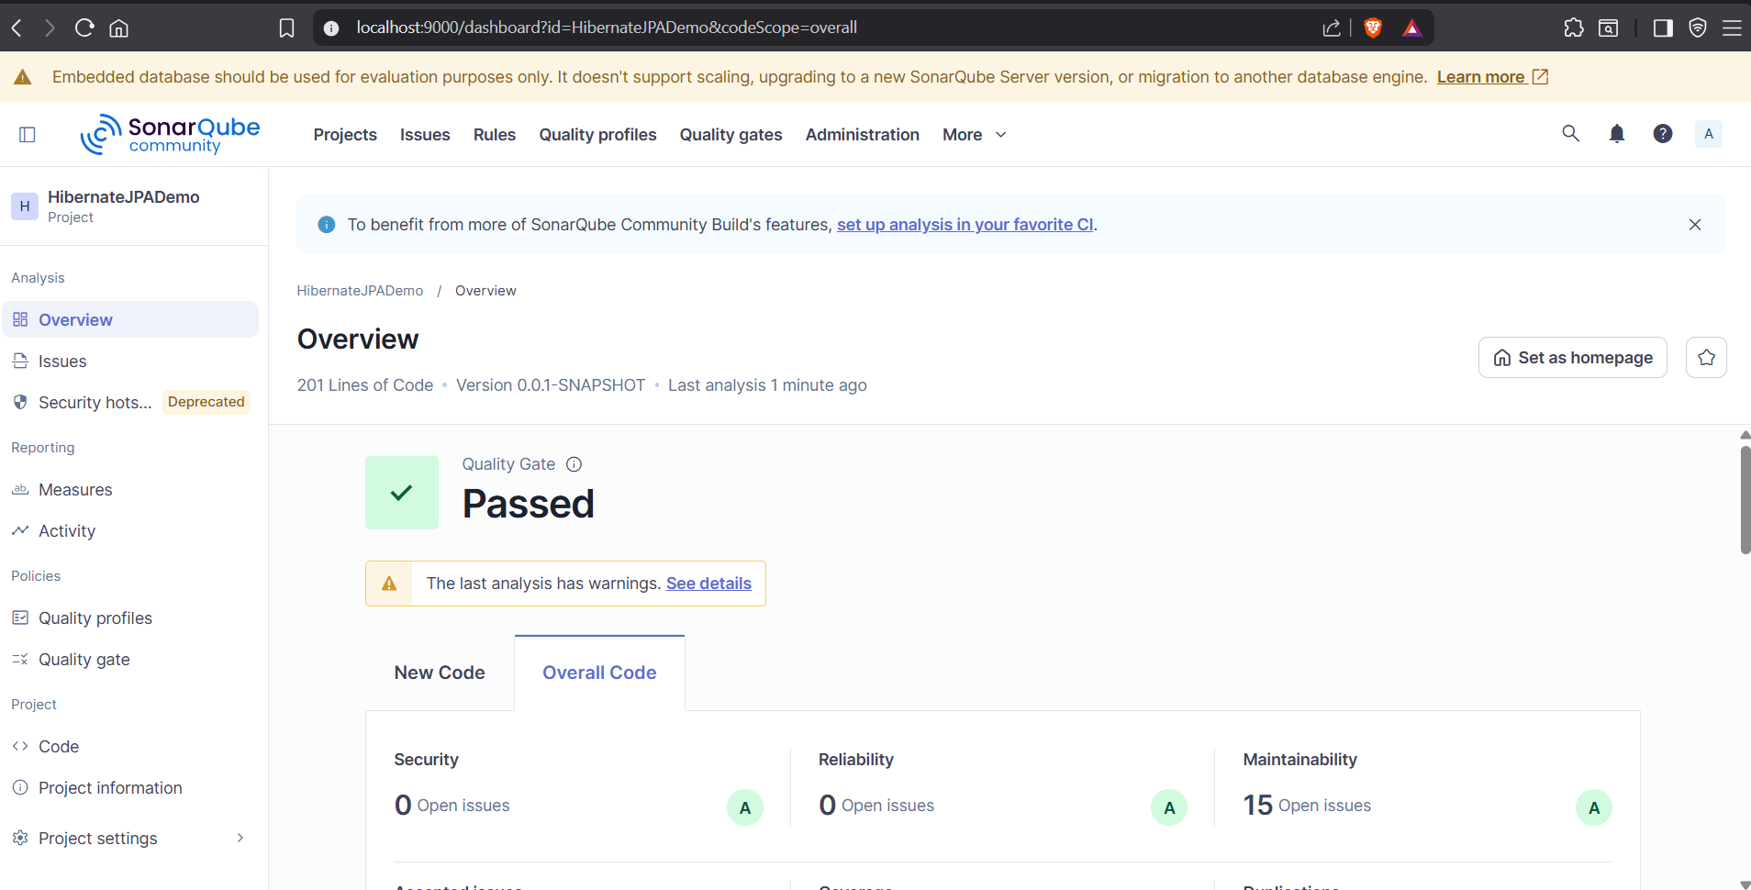

Intellij idea terminal output
